Date : 07/09/2026
Dear LK Domain Registry,
LK Domain Name Request: dgtravels.com.lk
I, Isum Sejan Gunasekara, bearing NIC No 200421203906 of No. 209/A, Hiru Wimana, Godauda Road, Hawpe, Imaduwa, Galle, Sri Lanka, have requested the above .LK Domain for the official website of DG Travels, a private transport and island-wide tour service trading from the same address under Business Registration No. [Business Registration No.]. The website will present our vehicle fleet, airport transfer and tour routes, and receive booking enquiries from travellers. The name “dgtravels” is taken directly from our trading name, DG Travels.
I further agree and acknowledge that (REGISTRANT’S Responsibility and Indemnification),
I agree that the Domain is used not to publish or upload any contents, comments and/or statements which are;
a. defamatory, slanderous, insulting and/or disparage any person, group of people, race, cast, Religion and/or nationality in general,
b. morally offensive, obscene and/or pornographic in nature,
c. illegal by law or prohibited/restricted by any prevailing or future court order and/or by any existing or future act of Parliament,
d. classified as global and/or national security information,
e. harmful to any person or organization including phishing, malware, virus etc.
f. Or any other similar activity.
I agree that the Domain Name may only be used for legitimate purposes under the Laws and Regulations of Sri Lanka and, and in accordance with LK Domain Registry Policies given at domains.lk/index.php/policies-conditions/domain-registration-policy
I agree that the Domain will not be used in any activity for which a License /Approval is required from the Government or any Regulatory Body without obtaining relevant License / Approvals including but not limited to Online Payments or any other Banking Activity, Liquor or controlled substances etc. (eg: If a name includes a word similar to ‘pay’, we need CBSL concurrence, or they should confirm that all payments are handled entirely by a CBSL approved payment processor)
I agree that the domain will not be used for any activity normally carried out by a Government body, or appears to be a Government Body unless you have specific authority to do so, including, but not limited to issuance of Visa, Permits etc.
I agree that any circumstances I breach the above conditions may lead the domain to be suspended or de-registered or without any notice to me.
Thank you,
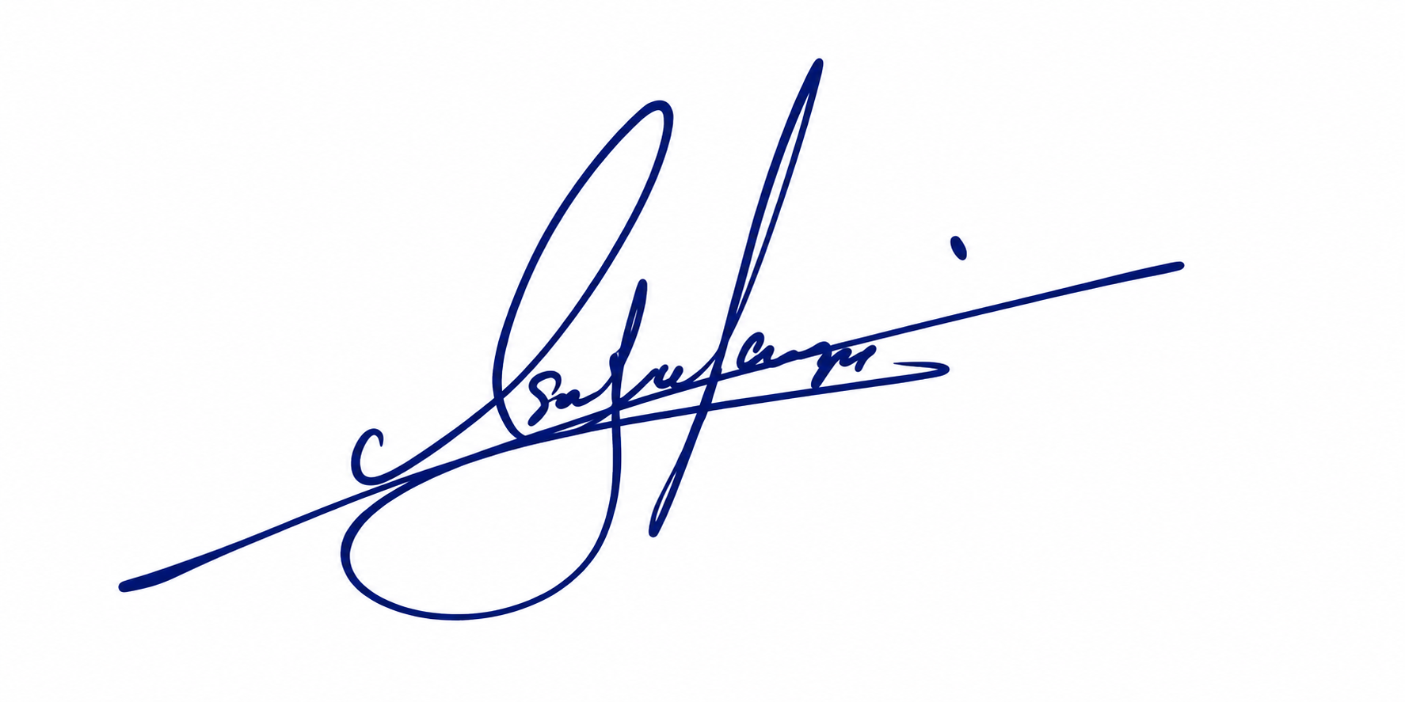

Isum Sejan Gunasekara
Date : 07/09/2026

